Social Media Forensics and Disinformation Tracking
ABSTRACT
Social media evolved as one of the major hubs of communication, but its misuse has led to many challenges, such as spreading disinformation, fake news, deep fakes and more. By using Digital forensics on social media, we can develop a strong approach to gathering, analyzing and identifying the collected data. Social media forensics evolved into an important and crucial research area, moreover media manipulation is a pressing problem in this field, where many struggle to identify between what is fake and what is real. The main aim of this paper is to dive deeper into the field of social media forensics, tracking fake propaganda, disinformation campaigns, tools used, and challenges faced. By analyzing the real-world cases we can understand the role of social media forensics in safeguarding the digital environment
- Introduction
Social media is mostly used to share information, express opinions, and communicate with others over digital landscape. However, Social media applications like Instagram, X, Facebook and Reddit are aimed at manipulating public opinion by spreading misinformation, digital impersonation and deep fakes. These fake posts have emerged and gained millions of views that have affected public opinion. The openness of these platforms gave rise to such threats.
Social media forensics involve gathering, analyzing, and identifying data from online to support investigators. It involves tracking user activity, finding fake accounts, detecting deep fakes and fake images which are generated by using AI tools and analyzing any found anomalies. Disinformation tracking mainly tracks the spread of false information or misleading information that has been circulating on social media platforms.
Due to the Continuous growth of social media and its influence on people, many disinformation monitoring and counter groups have been established to tackle the spread of miss information, such as Cogsec Collab and Beacon Project. Investigators must ensure evidence is collected systematically, preserving integrity, while maintaining legal and ethical frameworks. As misinformation techniques evolve (e.g., AI-generated content), the importance of social media forensics continues to grow.
- Types of Digital Evidence on Social Media
When investigating crimes involving social media, it’s not just checking saved posts, screenshots and comments. Investigators need to collect a wide variety of digital clues to understand what is happening and who is involved.
- Posts and Comments: Public Posts, Private messages, comments can give us a lot of information about someone’s actions or intentions. So, investigating these can give us users intentions and much more.
- Photos, Videos and Streams: When we share any posts on social media it also hides extra information which cannot be visible, basically this hidden data is what we call as metadata by using this we can connect all the dots. Ip address, location, device model, lens used, and date and time of event all these come under metadata.
- Account Information: Details like when the account is created, where and when it is created, what IP addresses were used to login to that account, and any phone numbers or emails linked to that account can help investigators to track back to real people
- Social Trends: By finding out who connects with who, followers, following, friends and tagged accounts can help investigators to find fake bots, or organized people who manipulate others by texting them online

- Disinformation and Deepfake Analysis
3.1 Disinformation Campaigns
Generally, disinformation refers to the deliberate spread of false information intended to mislead audiences. Organized campaigns use fake accounts, bots, and emotional content to manipulate public opinion. Tactics include:\n
Amplifying some conspiracy theories
Targeting the specific groups with tailored misinformation
Suppressing the true information which is through distraction techniques
Example: In the 2016 U.S. presidential election, operatives from the Russian-based Internet Research Agency spread divisive political content across social media networks to influence voter perceptions.

3.2 Deepfake Technologies
The Deepfakes use machine learning algorithms (especially GANs - Generative Adversarial Networks) to create some hyper fake videos. These can damage in many ways like reputations, influence political outcomes, or facilitate fraud.
Detection Techniques:
Frame Analysis: In the frame analysis we use Spotting pixel anomalies, lighting inconsistencies, or unnatural facial movements.
Audio Forensics: The audio forensics are mostly used for Identifying synthetic speech patterns.
Blockchain-Based Authenticity Verification: The Emerging technologies which allow cryptographic signing of authentic media which is at the point of capture.

- Tracking Online Harassment and Cybercrimes
Online harassment has become increasingly common today and includes forms such as cyberbullying, doxxing, stalking, and revenge porn. Investigators track perpetrators by:
Analyzing Posting Patterns: Investigators look at how often someone posts, at what times (which can hint at their time zone), and their language style or tone. These details can provide important clues about who’s behind the harassment.
Tracing IP Addresses: In serious cases, authorities may approach internet service providers (ISPs) with legal requests (like subpoenas) to match IP addresses with real users.
Spotting Fake or Duplicate Accounts: Duplicate accounts Known as "sockpuppet" accounts, these are fake profiles often created to mislead or harass. Investigators check for reused profile pictures, similar email IDs, or slight changes in usernames to uncover them.
Example: In 2021, TikTok saw a surge of "hate raids," where large groups of bots targeted and harassed creators from minority communities. These attacks weren’t random—they were planned. Digital forensic experts stepped in and, by closely studying the patterns in these bot activities, were able to trace them back to organized groups working behind the scenes.

- Case Studies
5.1 Case Study: 2016 U.S. Election Interference
In Russia, investigators discovered that operatives were using social media platforms like Facebook groups, fake pages, and Instagram ads to influence public opinion. Through digital forensic analysis of ads, posts, and metadata, experts were able to trace thousands of these accounts back to the Internet Research Agency based in St. Petersburg.
5.2 Case Study: Deepfake Celebrity Scandal
In the year 2019, a deepfake scandal surfaced involving synthetic videos that showed celebrities in compromising situations. Forensic experts stepped in and used frame-by-frame analysis to examine the footage closely. They spotted inconsistencies—like mismatched lighting between the faces and the background—which helped expose the videos as fake and debunk the material.
5.3 Case Study: Christchurch Shooting Livestream
There was a livestreamed terror attack in Christchurch in the year 2019, New Zealand, was rapidly shared across various social media platforms. Forensic teams collaborated with tech companies to trace how the video spread online. This investigation played a key role in pushing platforms to introduce stronger content moderation policies to prevent such incidents from going viral in the future.
- Forensic Tools and Techniques
SpiderFoot: SpiderFoot is an open-source OSINT automation tool. It helps gather public information about usernames, email addresses, domains, and IP addresses. It’s very useful for tracing fake social media accounts or mapping disinformation websites.
Maltego: Maltego is a powerful tool for visualizing relationships between entities. Investigators use it to map connections between accounts, domains, and email addresses — making it easier to see networks behind disinformation campaigns.
X1 Social Discovery: X1 Social Discovery is a specialized forensic tool for collecting evidence from social media platforms. It preserves posts, messages, comments, and metadata in a legally admissible way for court use.
Sherlock: Sherlock was used to identify the presence of suspicious usernames across multiple social media platforms. By mapping these accounts, we established digital linkages that suggested coordinated disinformation activities. This initial reconnaissance complemented deeper investigations carried out using SpiderFoot
We used Spiderfoot to gather information on domains, usernames and emails. Imagine a fake news website is identified as a source of disinformation. By querying SpiderFoot with the website's domain name, you could uncover related websites, social media accounts, or IP addresses that indicate a larger network of individuals or organizations involved in the dissemination of misinformation.

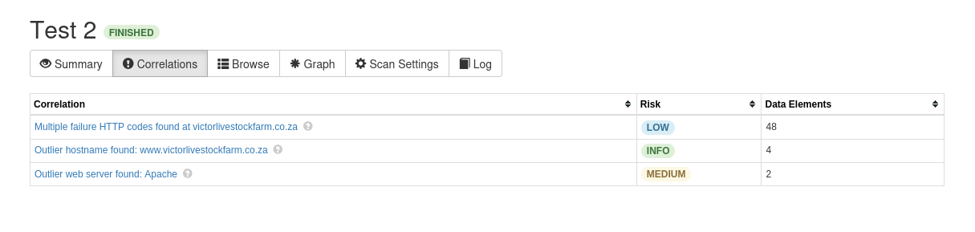
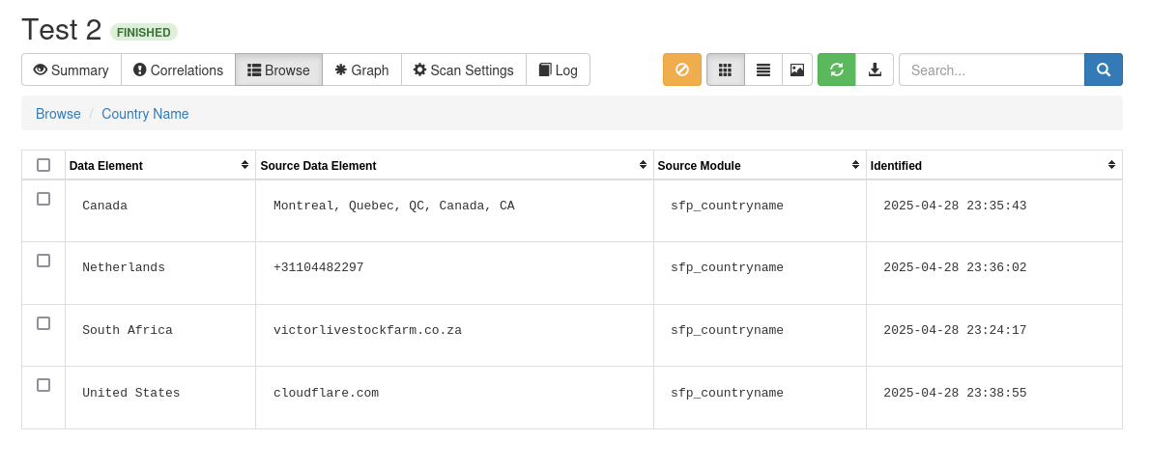
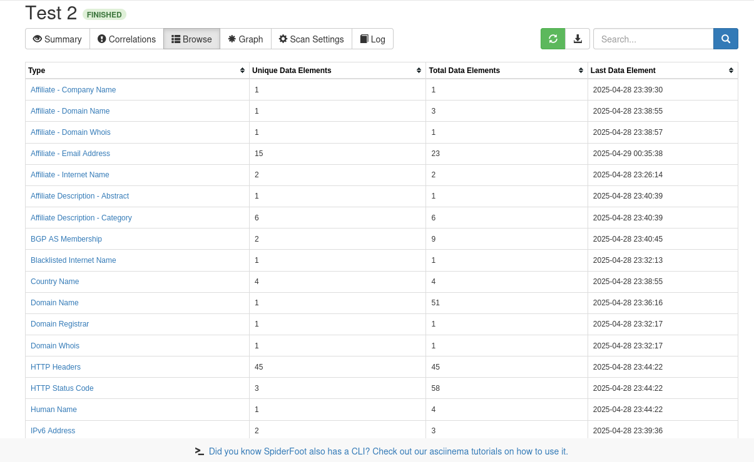
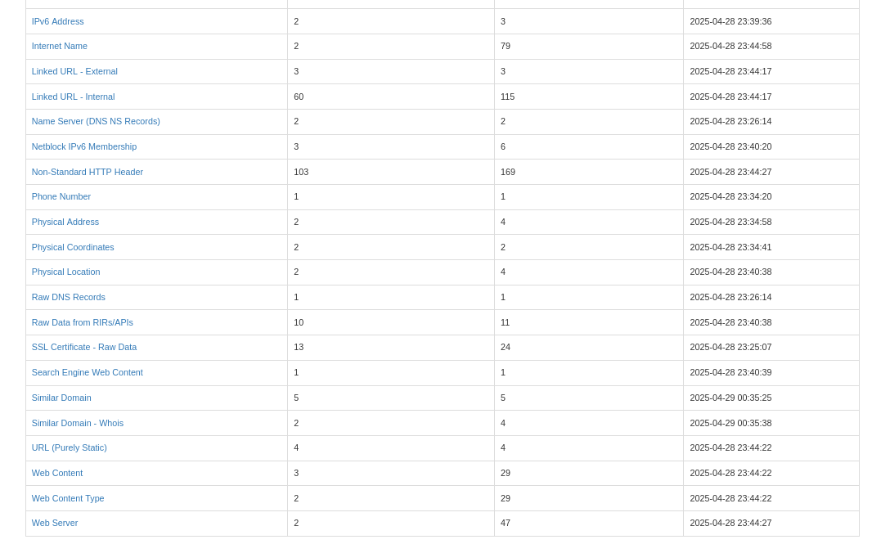
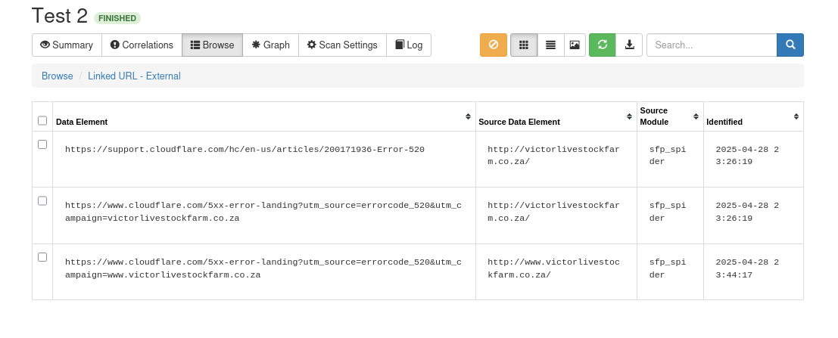
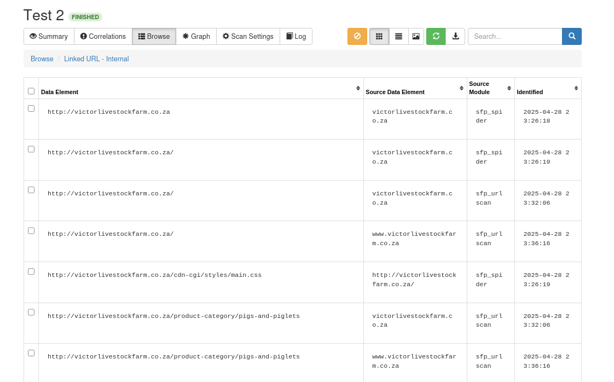
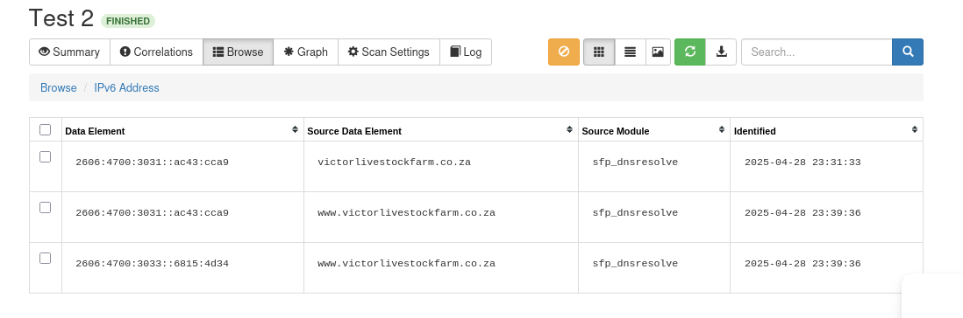
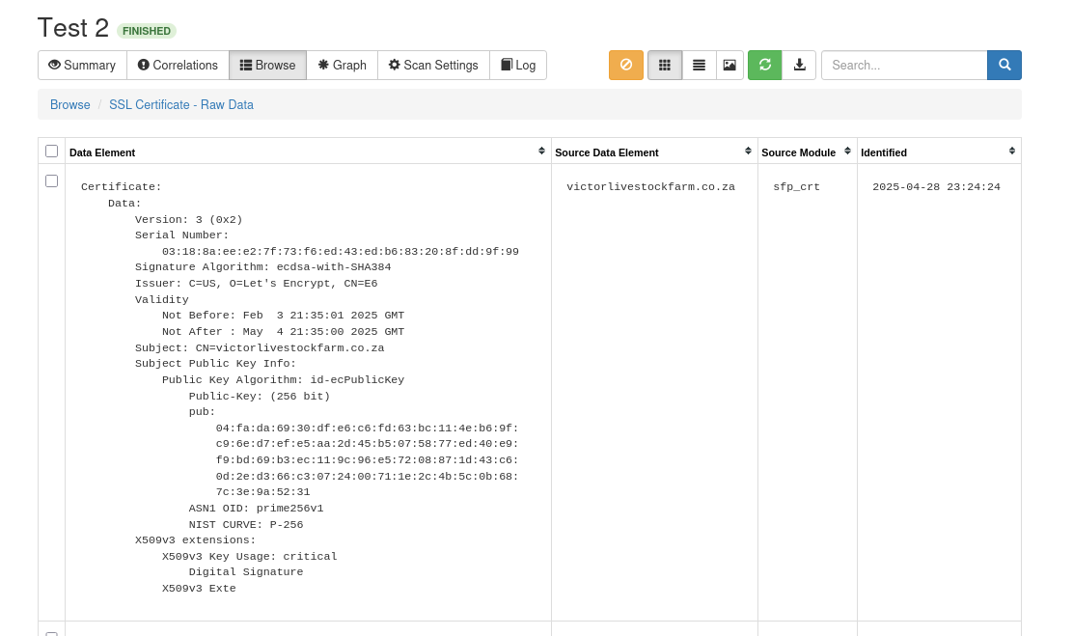
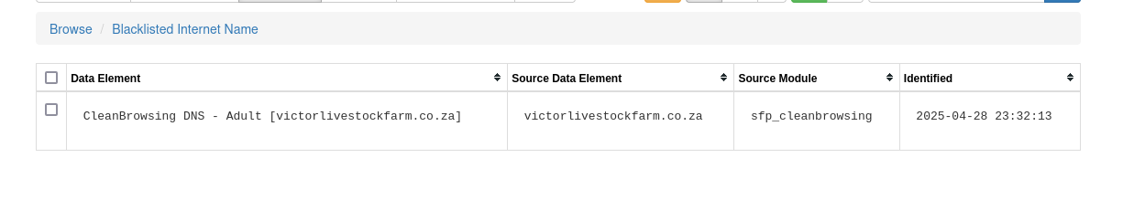
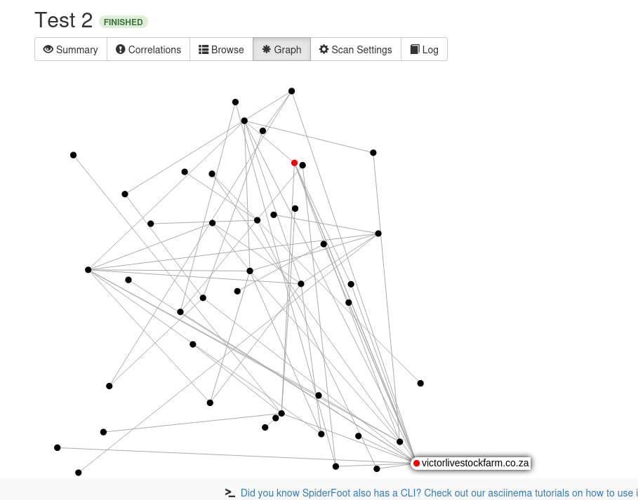
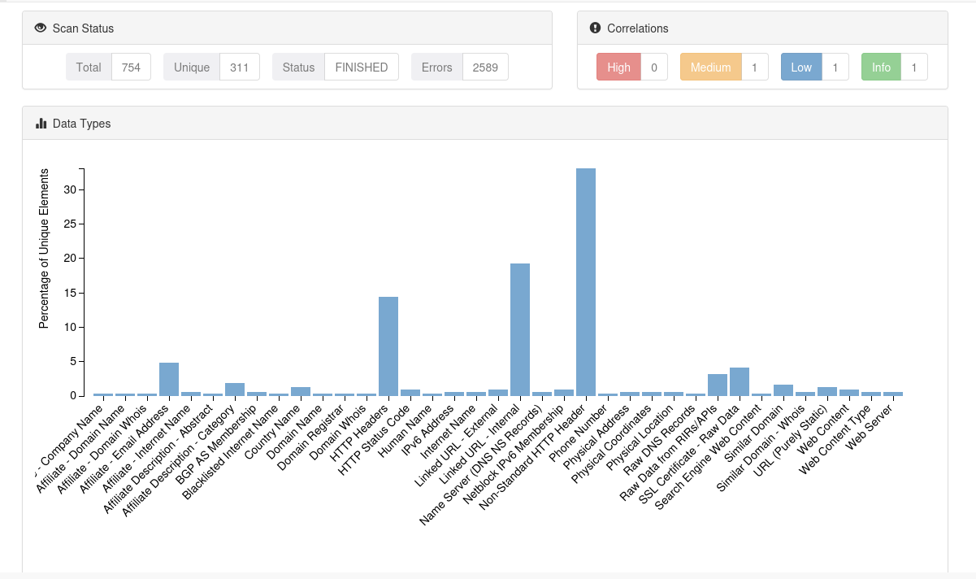

- Legal and Ethical Considerations
Jurisdictional Complexities
Social media platforms operate globally. Investigations involving foreign actors, like in election interference cases, face extradition issues, conflicting national laws, and diplomatic roadblocks.
Privacy Concerns
Investigators must tread carefully to avoid infringing privacy rights. Collecting private messages without proper warrants violates laws like: GDPR (General Data Protection Regulation - Europe) CCPA (California Consumer Privacy Act)
Ethical Challenges:
Misinformation vs Freedom of Expression: Overzealous removal of content risks silencing dissent.

